DMIT2008 Sample Report: Thinking in React
I’m going to do a sample report on Twitters’ user profile page for a deeper understanding of the architecture of a React application and how components interact with each other.

Start with a Mock
Here’s the page I’m going to be working with.
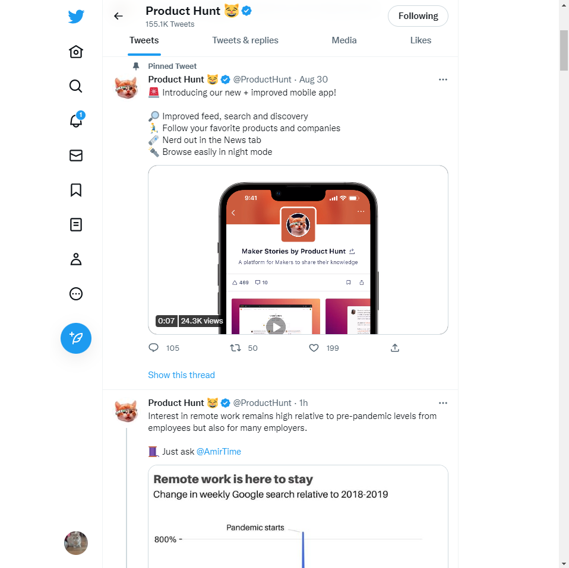
Functionality on this page:
- Liking a “tweet”
- Tweeting a “tweet”
- Retweeting a “tweet”
- Sharing a “tweet”
- Navigating the Tabs
- Going to a different page (left nav)
- Follow
You’ll also need to navigate to multiple pages on the left navigation and navigate through the tabs.
There’s a json api, fetched when we visit the page, that would probably take the shape of something like the following:
[
{
"id": "1",
"user":{
"name": "product hunt",
"handle": "@producthunt"
},
"tweet": "product hunt is awesome",
"video_url": "https://twittercdn.com/video/1234567890",
"comments": 50,
"retweets": 100,
"likes": 200
},
{
"id": "2",
"user":{
"name": "product hunt",
"handle": "@producthunt"
},
"tweet": "product hunt is awesome",
"video_url": "https://twittercdn.com/video/1234567890",
"comments": 50,
"retweets": 100,
"likes": 200
}
]

Break the UI into a Component Hierarchy
Here’s the image of the component break down.
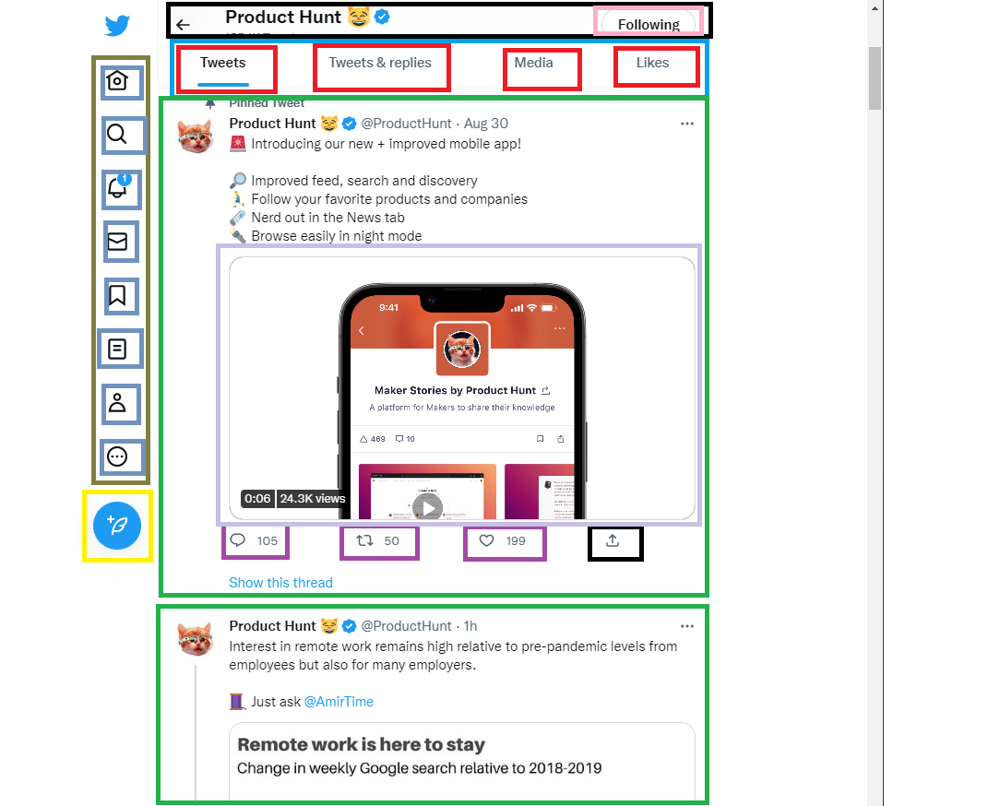
Below is the breakdown of the Components of the image above in a nested hierarchy.
- LeftNav (in weird brown) no props
  - Home Button (Twitter logo) no props
  - Icon Button (in weird blue) props: icon
  - Tweet Button (in yellow) no props.
- Container (the right side of the image) no props
  - HeadNavBar (in black) no props
    - Title props: title
    - FollowButton (in pink) props: “is following”
  - TweetTabs (in blue) no props
    - Tab (in red) props: text, “is active”
  - TweetTimeline (wrapping both green elements) no props
    - Tweet ( in green) this uses the api json. But the required props should be: user, tweet, comments, retweets, likes
      - TweetButton (in dark purple) props: icon, numberValue, actionTaken actionFunction
      - TweetVideo (in light purple) props: video_url
      - MoreActions (three dots in top right) no props

Minimal Representation of State
Based on the functionality above here’s the minimal representation of state:
- “following” is stateful value that is true or false and should live in the “FollowButton” if it’s true it should show “Following” and if it is not it should display “Follow” in the component. This will toggle if the button is clicked.
- “Retweet” and “Like” are stateful values and should live in the “Tweet” component and be either true or false based on if the user has either retweeted or liked this “tweet” this should be passed down to the “TweetButton” component so they can display the value and if it’s liked/retweeted. They will toggle if the button is clicked.
- “currentTab” is a stateful value that indicate which tab is active. This value would live in the “TweetTabs” component.
- tweeting or commenting on the page pops up a modal (which would be stateful open or not open), commenting would pop up the same modal. If I were to post a comment though, the state of the comments would need to be updated, and would be defined in a component modal (not included in this report).
- I didn’t include “sharing” function as this is more of an action that you can take with the tweet that wouldn’t be shown with state on the page.
- I didn’t include navigation as that does not need state and would navigate to a different page.

Static Mockup
If you included a static mockup just zip it up and hand it in alongside this report. Please explain your choices in a README.md file. I have not included a static mockup to this sample report.

